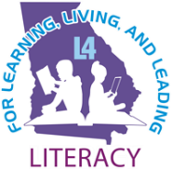
L4GA Grant Kickoff

Participant Agenda

July 7th-9th 2020 via Microsoft Teams App

*For IT Support Email: L4GASupport2020@gavirtualschool.org

DAY ONE: Tuesday, July 7th
9:00 am -11:00 am  Link to July 7th Morning Live Event HERE Click “Launch it Now” on webpage | Opening Remarks and Keynote Session  Welcome from L4GA Program Manager  Julie Morrill  Georgia State School Superintendent  Richard Woods  United States Department of Education  Dr. Sylvia Lyles  Georgia Deputy Superintendent of Teaching and Learning  Dr. Caitlin McMunn Dooley
11:00 am – 11:15 am | Break
11:15 am – 12:00  Participants follow links from Live Event Q&A Announcement or hotlinks on this agenda to join Meetings in Teams App | Regional Meeting Breakouts  July 7th Meeting 1: CSRA, First, Okefenokee, Heart of GA  July 7th Meeting 2: West, Griffin, Metro (incl GaDOE State Schools)  July 7th Meeting 3: Coastal Plains, Southwest  July 7th Meeting 4: Pioneer, Northwest, Northeast
12:00 pm – 1:00 pm | Lunch
1:00 pm – 2:00 pm  Link to July 7th Afternoon Live Event HERE Click “Launch it Now” on webpage | Leadership Session  Dr. Cary Riches, Executive Director of Secondary Education, Brandywine School District
2:00 pm – 2:15 pm | Break
Session 1: 2:15 pm – 2:35 pm  Session 2: 2:35 pm – 2:55 pm  Session 3: 2:55 pm – 3:15 pm | Office Hour Meetings  July 7th Meeting 5:  Community Partnerships and Evaluation of Systems  Dr. Roberta Gardner, Kennesaw State University  Dr. Meltem Alemdar, Georgia Tech  July 7th Meeting 6:  Evaluation for Continuous Improvement  Dr. Gary Bingham, Georgia State University  Dr. Rihana Mason, Georgia State University  July 7th Meeting 7:  Fiscal Management and Performance Plans  Regina Hailey, Georgia Department of Education  Julie Morrill, Georgia Department of Education
3:15 pm – 4:00 pm  Link to July 7th Q&A Live Event HERE Click “Launch it Now” on webpage | L4GA Team Q&A

Georgia Department of Education/L4GA Team
Caitlin McMunn Dooley, PhD  Deputy Superintendent for Teaching & Learning  Georgia Department of Education  cdooley@doe.k12.ga.us | Justin Hill, Director of Curriculum & Instruction  Georgia Department of Education  juhill@doe.k12.ga.us
Julie Morrill, Program Manager L4GA/Literacy  Georgia Department of Education  jmorrill@doe.k12.ga.us | Lisa Albert, Program Specialist L4GA  Georgia Department of Education  lisa.albert@doe.k12.ga.us
Sian Lott, Program Specialist L4GA  Georgia Department of Education  slott@doe.k12.ga.us | Holly Schmidt-Davis, L4GA Evaluation and Research Specialist  Georgia Department of Education  holly.schmit-davis@doe.k12.ga.us
Meghan Welch, PhD, Program Specialist L4GA/Literacy
Georgia Department of Education
mwelch@doe.k12.ga.us

Building Community Engagement and Applying the Four Pillar Framework

DAY TWO: Wednesday, July 8th
9:00 am -11:15 am  Link to July 8th Morning Live Event HERE Click “Launch it Now” on webpage | Morning Session  Welcome and Greetings  Dr. Caitlin Dooley, Georgia Department of Education  Julie Morrill, Georgia Department of Education  Inspiration  Carmen Deedy, Children’s Author  What is the Campaign?  Arianne Weldon, Strategic Innovation Manager, & GGR Campaign Director, GaFCP  Current L4GA Community  Jamie Ray, L4GA Grant Administrator, Dublin City Schools  Betsy Glisson, L4GA Grant Administrator, Laurens County Schools;  Engagement and Reflection  Participants: Please use the Q&A to ask questions and make observations.  Moderator: Akia Lewis, Strategic Innovation Manager, & GGR Campaign Director, GaFCP  Language Nutrition  Ami Klin, Director, Marcus Autism Center  Next Steps Live Q&A: Language Nutrition opportunities and known activities in your communities.  Moderator: Mary Willoughby, Consultant, GGR Campaign
11:15 am -1:00 pm | Break and Lunch

DAY TWO: Afternoon Session
1:00 pm – 3:00 pm  Link to July 8th Afternoon Live Event HERE Click “Launch it Now” on webpage | Afternoon Session  Welcome Back and Agenda Review  Arianne Weldon, Strategic Innovation Manager, & GGR Campaign Director, GaFCP  Access Pillar, Theory Presentation  Judge Wenona Belton, Fulton County Juvenile Court  Access Pillar, Practice Presenter  Dr. Ebony Lee, Clayton County Assistant Superintendent  Engagement and Reflection  Participants: Please use the Q&A to ask questions and make observations.  Moderator: Akia Lewis, Strategic Innovation Manager, & GGR Campaign Director, GaFCP  Teacher Preparation  Nicole Patton Terry, PhD  Associate Director Florida Center for Reading Research  Engagement and Reflection  Participants: Please use the Q&A to ask questions and make observations.  Moderator: Akia Lewis, Strategic Innovation Manager, & GGR Campaign Director, GaFCP  Regional Data Walk  Mike Carnathan, Manager, Research & Analytics Division,  Atlanta Regional Commission  Next Steps Live Q&A: Increasing access in communities: Brainstorm in Q&A chat  Moderator: Mary Willoughby, Consultant, GGR Campaign

Building Community Engagement and Applying the Four Pillar Framework

DAY THREE: Thursday, July 9th
9:00 am -10:20 am  Link to July 9th Morning Live Event HERE Click “Launch it Now” on webpage | Morning Session  Welcome Back and Agenda Review  Arianne Weldon, Strategic Innovation Manager, & GGR Campaign Director, GaFCP  Inspiration  Randy Nix, State Representative (R-LaGrange),  Georgia House of Representatives  Climate Theory & Practice  Garry McGiboney, Deputy Superintendent, Office of School Safety and Climate, Georgia Department of Education  Live Q&A  Engagement and Reflection  Participants: Please use the Q&A to ask questions and make observations.  Moderator: Akia Lewis, Strategic Innovation Manager, & GGR Campaign Director, GaFCP  Next Steps Live Q&A: Who sets the tone for climate in your setting? How can climate be improved?  Moderator: Mary Willoughby, Consultant, GGR Campaign  Transition to Meeting Breakouts
10:30-11:30  Participants follow links from Live Event Q&A Announcement or hotlinks on this agenda to join Meetings in Teams App | Grade Band Meeting Breakouts  July 9th Meeting 1: B5  July 9th Meeting 2: Elementary  July 9th Meeting 3: Middle  July 9th Meeting 4: High

Stakeholder Exercise
Brief four pillar review- facilitator will remind participants of framework and post four pillar image on screen while briefly describing – 5 min

Describes stakeholder exercise – considering the various talks and experiences shared so far, who in our community has the potential to work with us to improve L4 outcomes? Think about who is already on the team, and in a second list, think about who is needed to engage in the effort to improve results. List in chat and discuss – facilitator has prompting questions ready to start conversation rolling – participants may speak or write some of their responses.

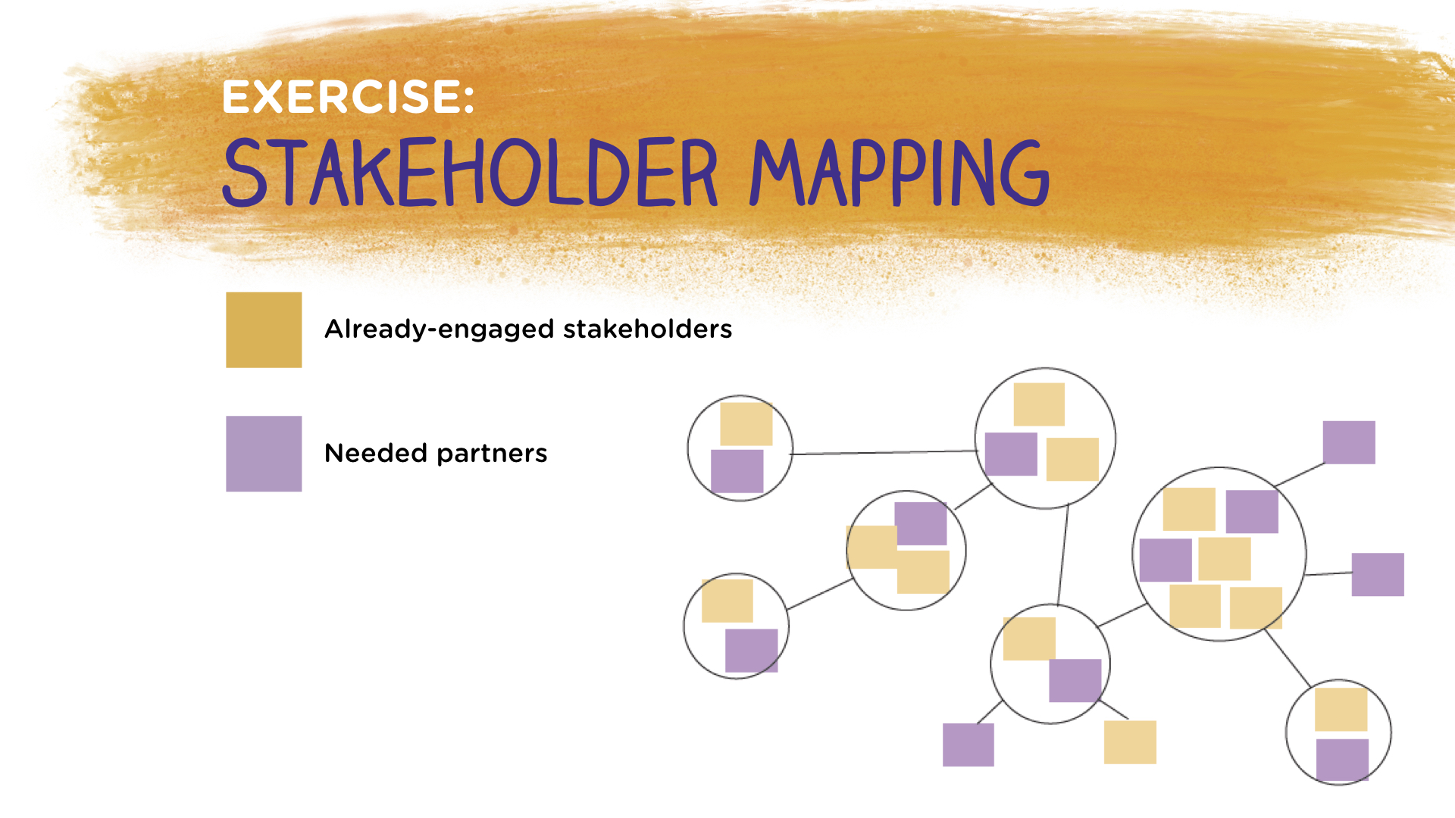

During exercise session, moderator will be reflecting items in chat to group verbally. Session observer will prepare notes to report from meeting to Live event – each group will be asked to report on 3 essential and already engaged stakeholders and to identify 3 needed but not yet engaged stakeholder groups

11:30 am -1:00 pm | Break and Lunch

DAY THREE: Afternoon Session
1:00 pm – 3:00 pm  Link to July 9th Afternoon Live Event HERE Click “Launch it Now” on webpage | Afternoon Session  Welcome Back & Introduce Observers  Mary Willoughby, Consultant, GGR Campaign  Report Observations  B5, Bridgette Washington  Elem, Debbie Alexander  Middle, Kimberly Creagh  High, Marcell Johnson  Putting it All Together in the Community  Sarah Lee Crumbs, Coordinator, Quitman County Family Connection  Putting it All Together in the Classroom  Emily Rubin, Director, Communication Crossroads  Live Q&A  Engagement and Reflection  Participants: Please use the Q&A to ask questions and make observations.  Moderator: Akia Lewis, Strategic Innovation Manager, & GGR Campaign Director, GaFCP  Next Steps Live Q&A: What is the first thing I will do when returning to the community planning table?  2:15-2:30 Mary Willoughby to moderate Live Q&A  Wrap-Up Survey and Announcements  Julie Morrill, L4GA Program Manager,  Georgia Department of Education  A Personal Charge  Hayward Cordy, Executive Director, Oconee RESA

Georgia Family Connection Partnership/
Get Georgia Reading Campaign Team

Akia Lewis, Strategic Innovation & Get Georgia Reading Campaign Manager  Georgia Family Connection Partnership | Sarah Torian, Consultant  GGR Campaign
Arianne Weldon, Strategic Innovation Manager & Get Georgia Reading Campaign Director,  Georgia Family Connection Partnership | Mary Willoughby, Consultant  Get Georgia Reading Campaign

Thank you all for your support and participation! This is the beginning of an exciting journey as an L4GA district.

Thank you to the Georgia Virtual School IT Team for guiding us through our first virtual conference.

